REPRODUCTION AND DEVELOPMENT

Sexual Reproduction

• Involves two parents and two sex cells.
• Plants have the following sex cells.

Flowers - pollen (male) and ovule (female).
Conifers - male and female cones.
Ferns, mosses, fungi - can produce spores from sex cells joining.

• Animals have sperm (male) and ova (female).
• Internal fertilisation - occurs for land living animals.
- high degree of parental care.
- only a few eggs produced.
• External fertilisation - occurs for water living animals.
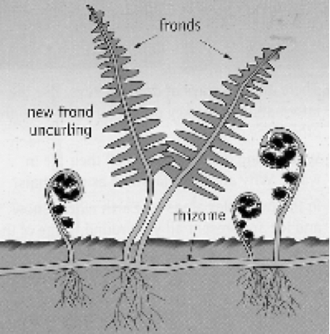
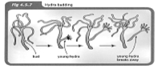
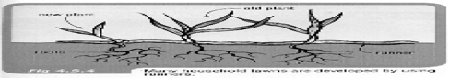
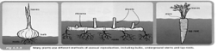
- no parental care.
- thousands of eggs produced to have a few survive.

Asexual Reproduction

• Occurs in a few animals - usually very simple
animals.

e.g. protozoa, hydra, sea stars (if part of the
central disc is intact).

• Occurs in many plants and there are several
types.

Cuttings of plants (e.g. geraniums)
Grafts (e.g. roses)
Runners (e.g. grass)
Bulbs (e.g. onion)
Underground stems (rhizomes) (e.g. bamboo)
Tap root (e.g. carrots)
Spores (e.g. mushrooms)

